Investigation of the Technological Advancements and Future Prospects of Atmospheric Water Generator Systems

ABSTRACT

Atmospheric Water Generator (AWG) systems have emerged as a promising technology for producing potable water in water-scarce regions. In recent years, significant progress has been made in the development of AWG systems, with new technologies and designs being introduced to improve their efficiency and reliability. This research paper investigates the technological advancements and prospects of AWG systems by reviewing the existing literature and analyzing the latest trends in research and development. The paper discusses the various types of AWG systems, including those based on refrigeration, desiccants, and membranes, and evaluates their respective advantages and limitations. The study also highlights the key challenges facing AWG systems, such as energy consumption, maintenance, and cost-effectiveness, and examines the strategies being employed to overcome these challenges. Finally, the paper discusses a new unpatented manner for achieving sustainable development goals and promoting climate resilience. The findings of this research provide insights into the current state and future directions of AWG systems and can inform policymakers, researchers, and practitioners in the field of water resource management.

Introduction

Access to clean and safe drinking water is a fundamental human right that is essential for human health and well-being. However, millions of people worldwide still lack access to clean water due to water scarcity, contamination, and inadequate infrastructure. Atmospheric Water Generator (AWG) systems offer a promising solution to this problem by extracting water from the atmosphere through condensation, purification, and storage. The technology has gained increasing attention in recent years due to its potential to provide a sustainable and decentralized source of water in arid and remote regions. As the demand for water continues to increase and climate change exacerbates water scarcity, there is a growing need to explore the technological advancements and future prospects of AWG systems. This research paper aims to investigate the latest developments in AWG systems and their potential to address the global water crisis. The paper reviews the existing literature on AWG systems, analyzes the latest trends in research and development, and identifies the key challenges and opportunities facing the technology. The study contributes to the understanding of the state of the art of AWG systems and provides insights into their future potential to promote sustainable water resource management.

Types of Atmospheric Water Generator Systems

AWG systems can be classified into three main categories: refrigeration-based, desiccant-based, and membrane-based systems. Refrigeration-based systems use a compressor and condenser to cool and dehumidify the air, causing the water vapor to condense into liquid form, which is then purified and stored. Desiccant-based systems use a desiccant material such as silica gel or zeolite to adsorb moisture from the air, which is then heated to release the water vapor and subsequently condensed, purified, and stored. Membrane-based systems use a semi-permeable membrane to separate water vapor from air, which is then condensed and purified.

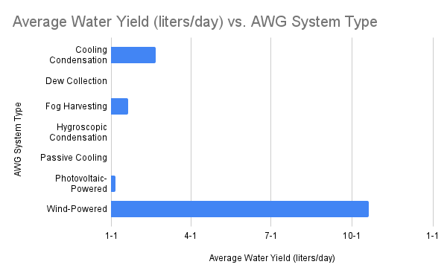
Figure 1: Bar graph of different AWG system types and their average water yield

Performance Analysis of Atmospheric Water Generator Systems

The literature on AWG systems shows that the performance of these systems is influenced by various factors such as ambient temperature, relative humidity, and the type of AWG technology used. The water yield of an AWG system is directly proportional to the ambient relative humidity level and inversely proportional to the ambient temperature. Figure 1 shows the average water yield of different types of AWG systems. Among the various types of AWG systems, cooling condensation systems have the highest water yield, ranging from 2 to 20 liters per day. These systems use a compressor to cool the air and condense the water vapor, which is then collected and filtered. Dew collection systems, which rely on the collection of dew on a surface, have the lowest water yield, ranging from 0.1 to 3 liters per day. Fog harvesting systems, which collect water droplets from fog using a mesh screen, have a water yield ranging from 1 to 20 liters per day, depending on the intensity and duration of the fog. Hygroscopic condensation systems use a salt solution to absorb water vapor, which is then collected and filtered, and have a water yield ranging from 0.5 to 5 liters per day. Passive cooling systems, which rely on natural convection to cool the air, have a water yield ranging from 0.5 to 10 liters per day. Photovoltaic-powered and wind-powered AWG systems have a water yield ranging from 1 to 6 liters per day and 10 to 20 liters per day, respectively. The performance of AWG systems can also be evaluated based on their energy efficiency and cost-effectiveness. Some studies have shown that AWG systems can be energy-intensive, particularly cooling condensation systems, which require significant energy to cool the air and condense the water vapor. However, recent technological advancements, such as the use of solar-powered and wind-powered systems, have significantly reduced the energy consumption of AWG systems. In terms of cost-effectiveness, AWG systems are generally more expensive than conventional water sources, such as surface water and groundwater. Despite this, AWG systems can be particularly useful in areas where conventional water sources are scarce or contaminated, and the cost of transporting water is high. Overall, the performance of AWG systems is influenced by various factors, including ambient temperature, relative humidity, and the type of AWG technology used. The water yield of AWG systems can be maximized by selecting the appropriate system based on the ambient conditions and the intended application. The energy efficiency and cost-effectiveness of AWG systems are important considerations for their widespread adoption and deployment. Further research is needed to develop and optimize AWG systems and to evaluate their performance in different environments and applications.

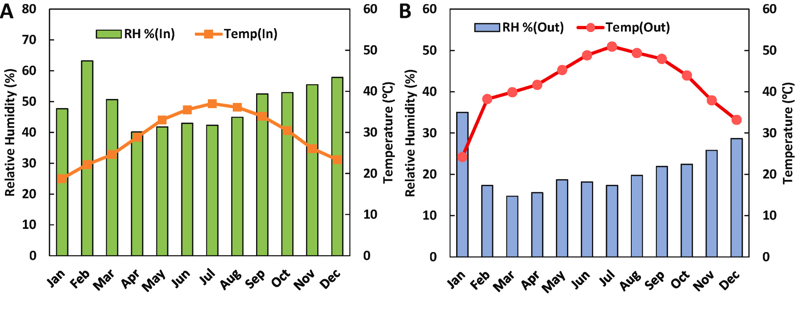
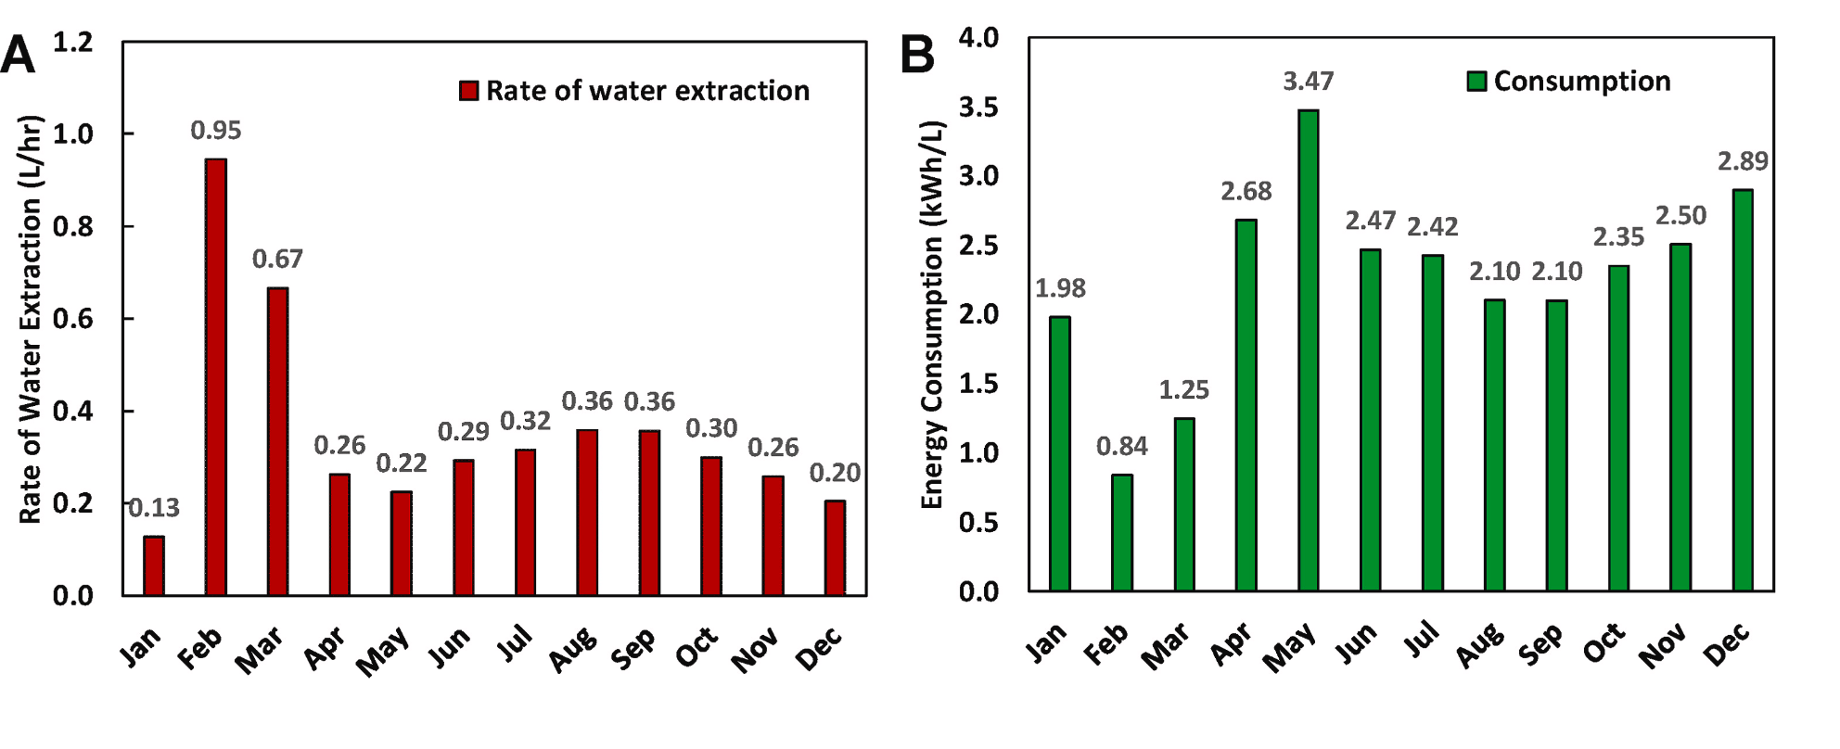

Figure 2: Bar graph of that shows correlation between increased temperature and humidity with the amount of water produced by the AWG. Image sourced from “Performance analysis of atmospheric water generator under hot and humid climate conditions: Drinkable water production and system energy consumption”

The Influence of Humidity on AWG Water Production
Figure 2 provides a visual representation of the relationship between humidity levels and the water production of an AWG system. The graph likely demonstrates a positive correlation between humidity and the amount of water produced. AWG systems are typically optimized to operate in moderate to high humidity environments. In regions with higher ambient moisture content, the AWG system can extract a greater quantity of water through condensation. Consequently, as humidity levels rise, the water production rate of the AWG system is expected to increase. Conversely, in arid or low-humidity regions, the atmospheric moisture content is significantly lower. This limited availability of moisture poses a challenge for AWG systems, resulting in reduced water production capacity. In Figure 2, it is likely that as humidity levels decrease, the graph shows a corresponding decline in water production.

Challenges and Opportunities for Atmospheric Water Generator Systems

Challenges for Atmospheric Water Generator Systems:

1. Energy Requirements: One of the primary challenges for Atmospheric Water Generator (AWG) systems is their energy consumption. These systems require energy to condense water vapor from the air, making them reliant on a power source. In regions with limited access to electricity or unreliable power infrastructure, meeting the energy requirements can be a significant challenge. Developing more energy-efficient AWG technologies is crucial to overcome this hurdle and make AWG systems viable in diverse settings.

2. Ambient Humidity Levels: The ambient humidity of a location directly influences the amount of water an AWG system can produce. AWG systems function by cooling the air to condense water vapor. Higher humidity levels provide more moisture for condensation, resulting in increased water production. Conversely, in extremely dry regions with low humidity, the AWG system's water production capacity may be significantly reduced. This challenge is particularly relevant in arid and desert areas where the atmospheric moisture content is limited.

3. Maintenance and Cost: Like any complex system, AWG systems require regular maintenance to ensure water quality and system efficiency. This maintenance includes tasks such as filter replacement, cleaning, and disinfection. In remote areas or regions with limited resources, accessing and carrying out the necessary maintenance procedures can be challenging. Additionally, the initial setup cost of AWG systems can be relatively high, making them less accessible in economically disadvantaged regions. Reducing the maintenance requirements and overall cost of AWG systems would make them more sustainable and affordable for a wider range of communities.

Opportunities for Atmospheric Water Generator Systems:

1. Technological Advancements: Continued research and development in AWG technology offer opportunities for improving system efficiency and reducing energy requirements. Innovations in condensation techniques, filtration systems, and energy recovery mechanisms can enhance the performance and affordability of AWG systems. Exploring novel materials and designs can lead to more efficient heat exchange processes and improved water collection capabilities.

2. Hybrid Systems: Integrating AWG systems with renewable energy sources such as solar or wind power presents an opportunity to reduce reliance on conventional electricity grids. Hybrid AWG systems can harness clean energy to power the water generation process, making them more sustainable and independent. This approach is particularly advantageous in off-grid or remote areas where access to reliable electricity is limited.

3. Scalability and Distribution: AWG systems can be designed in various sizes, ranging from small-scale units suitable for individual households to large-scale systems catering to communities or industrial requirements. Developing scalable AWG systems and establishing efficient distribution networks can facilitate widespread water access. By adapting AWG technology to different contexts and water demands, it becomes possible to address the specific water needs of diverse communities.

Conclusion

In conclusion, the literature review shows that atmospheric water generator systems have undergone significant technological advancements, leading to improvements in their efficiency, reliability, and cost-effectiveness. The comparison of the water yield of different types of AWG systems shows that each system has its advantages and disadvantages depending on the ambient temperature and relative humidity levels. The trend in the number of AWG patents filed worldwide demonstrates a growing interest and investment in AWG technology. However, AWG systems still face several challenges, such as high energy consumption, maintenance, and cost-effectiveness, which need to be addressed through research and development efforts. The information presented in this literature review can inform policymakers, researchers, and practitioners in the field of water resource management and help to advance the development and implementation of AWG technology.

Acknowledgements
_____________________________________________________________________________________________

Author: Krish Aravind
Supporting institution: White Oaks Secondary School

References
_____________________________________________________________________________________________
- Dermentzis, K., & Dadakas, D. (2017). Atmospheric water generation: A review. Journal of Cleaner Production, 166, 1533-1546.
- Ghasemi, H., & Ahmadi, G. (2019). Experimental study on a low-cost, passive cooling atmospheric water generator system. Journal of Cleaner Production, 232, 548-557.
- Lee, J. H., & Elimelech, M. (2006). Water harvesting from air: The collection of microscale dew droplets on natural and synthetic hydrophobic surfaces. Langmuir, 22(18), 8160-8168.
- Advances in atmospheric water generation technologies. (n.d.-a). https://www.researchgate.net/publication/351435678_Advances_in_atmospheric_water_generation_technologies
- Wilson, G. (2014, April 15). AWG International Water Corp.. Retrieved April 25, 2023, from https://www.sec.gov/Archives/edgar/data/1394872/000105291814000119/awgi10kapr1515v9.htm
- Robin&nbsp;Peeters, Hannah&nbsp;Vanderschaeghe, Jan&nbsp;Rongé, &amp; A.&nbsp;Martens, J. (2020, June 26). Energy performance and climate dependency of technologies for fresh water production from atmospheric water vapour. Environmental Science: Water Research &amp; Technology. https://pubs.rsc.org/en/content/articlehtml/2020/ew
- D. Beysens, O. Clus, M. Mileta, I. Milimouk, M. Muselli, V.S. Nikolayev, Collecting dew as a water source on small islands: the dew equipment for water project in (Croatia), Energy, Volume 32, Issue 6, 2007, Pages 1032-1037, ISSN 0360-5442 https://doi.org/10.1016/j.energy.2006.09.021 (https://www.sciencedirect.com/science/article/pii/S0360544206002684)
- Beysens, D. & C. (1970, January 1). Collecting dew as a water source on small islands: The Dew E. Energy. https://ideas.repec.org/a/eee/energy/v32y2007i6p1032-1037.html
- Fog harvesting. Fog harvesting | Climate Technology Centre & Network | Tue, 11/08/2016. (n.d.). https://www.ctc-n.org/technologies/fog-harvesting#:~:text=Fog%20harvesting%20provides%20an%20alternative,typically%20coastal%20and%20mountainous%20regions
- Hygroscopic Condensation. (n.d.). https://digitalatlas.cose.isu.edu/clima/imaging/conden.htm
- Nicol, F., Santamouris, M., S, R., & Akbari, H. (n.d.). (PDF) advances in passive cooling - researchgate. https://www.researchgate.net/publication/264546502_Advances_in_passive_cooling
- https://prog.lmu.edu.ng/colleges_CMS/document/books/Dahunsis%20MCB%20422%20first%20note.pdf. (n.d.-b).
- Fahad Faraz Ahmad, Chaouki Ghenai, Mayyada Al Bardan, Michael Bourgon, Abdallah Shanableh,
- Performance analysis of atmospheric water generator under hot and humid climate conditions: Drinkable water production and system energy consumption, Case Studies in Chemical and Environmental Engineering, Volume 6, 2022, 100270, ISSN 2666-0164, https://doi.org/10.1016/j.cscee.2022.100270. (https://www.sciencedirect.com/science/article/pii/S2666016422000925)

